Practical – 3

Responsive UI Design using CSS Grid, Flexbox, and Bootstrap/Tailwind
Problem Definition : Design responsive layouts for Home, About, Registration, Dashboard, and Events pages using CSS Grid and Flexbox. Optional to use CSS framework such as Bootstrap or Tailwind. Ensure mobile-first responsiveness.
A. THEORY
1. How does the layout adapt for mobile, tablet, and desktop screens?
The layout is made responsive using CSS media queries. The content, images, and navigation adjust according to the screen size of mobile, tablet, and desktop devices.
2. Which layout technique is used and why?
Flexbox is used to arrange the elements because it makes the layout flexible, responsive, and easy to align.
3. Are typography, spacing, colors, and contrast readable?
Yes. Suitable font sizes, spacing, colors, and contrast are used so that the content is clear and easy to read.
4. Is the framework used consistently without unnecessary inline CSS?
Yes. CSS is mainly written in external CSS files and applied consistently across the pages. Unnecessary inline CSS is avoided.

References
- MDN Web Docs – CSS Media Queries
- MDN Web Docs – CSS Flexbox
- MDN Web Docs – CSS Colors
- W3C – Web Accessibility Initiative

B. Implementation/ Output/Result
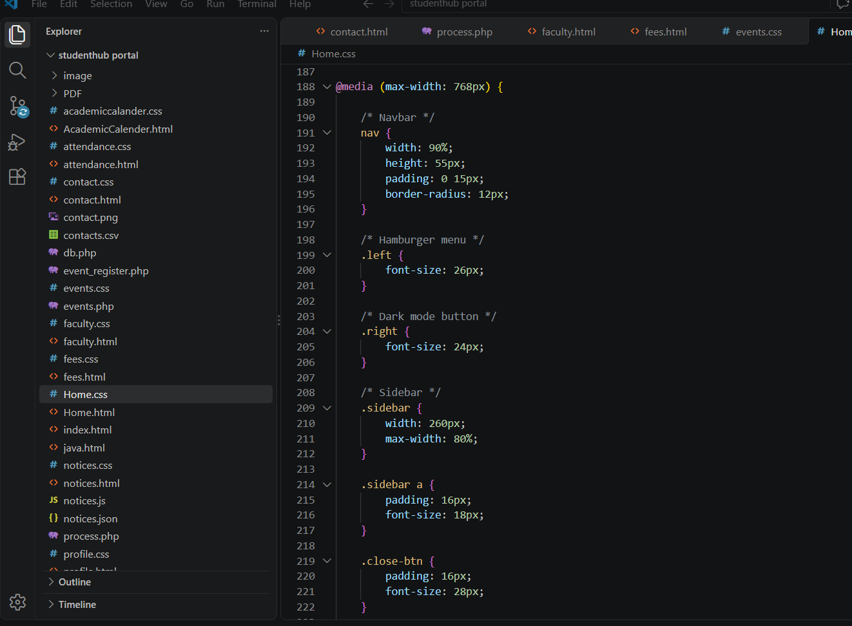

C. Evidence of Work (Screenshots)
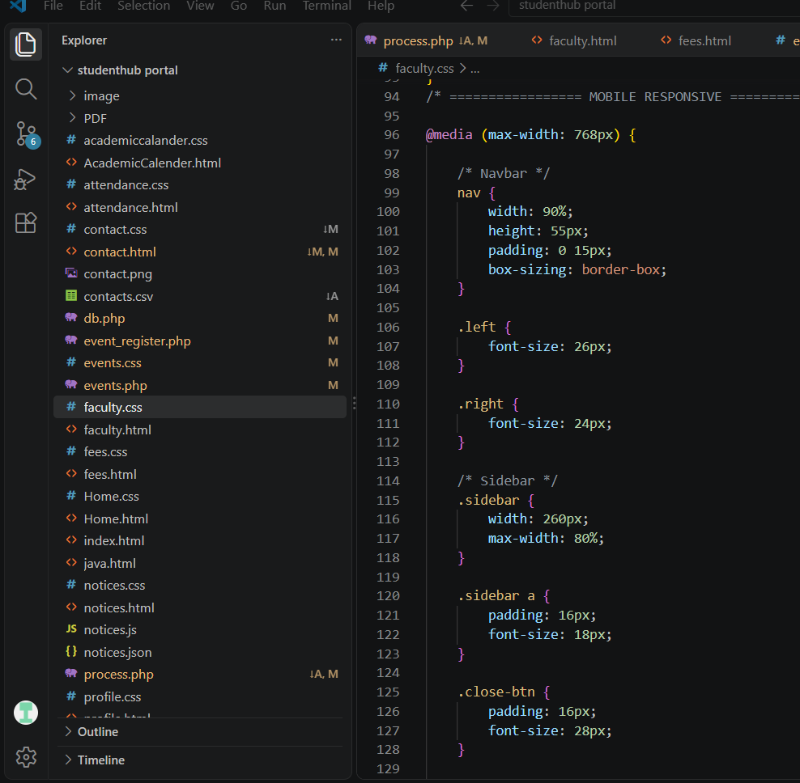
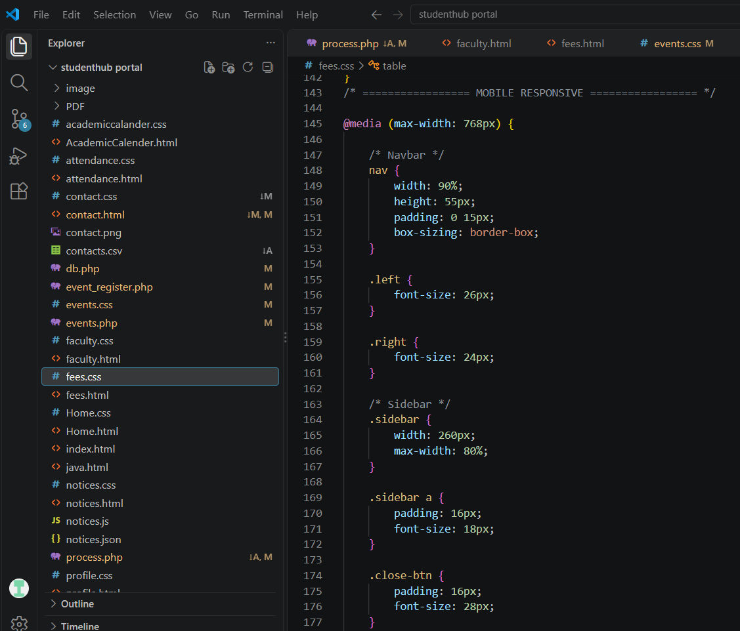

D. GitHub Repository Link
https://github.com/NencyNVagadiya/Student-Hub-portal/blob/main/contact.css

E. Challenges Faced:
“I faced difficulty in making the website responsive on both desktop and mobile screens, especially adjusting the sidebar, cards, forms, and navigation using Flexbox, Grid, and media queries.”
F. Learning Outcomes:
Students will design a professional, responsive, and reusable UI layout.

G. Faculty Remarks:

